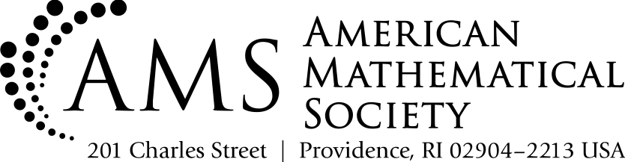**Editorial Division**

*acquisitions@ams.org*

**www.ams.org**

**AMS-MAA Book Submission Form**

*Working title:* Alexandrov geometry: foundations

*Expected completion date: ready*

*Authors' full names:* Stephanie Alexander, Vitali Kapovitch, and Anton Petrunin

*E-mail addresses:* stephanieb.alexander@gmail.com, petrunin@math.psu.edu, vtk@math.toronto.edu.

*Authors’ addresses: (corresponding author)*

*Anton Petrunin*

*Math. Dept., PSU   
University Park, PA 16802*

*Previous books by Authors (including year, title, publisher):*

*An invitation to Alexandrov geometry. CAT(0) spaces. SpringerBriefs in Mathematics. Springer, Cham, 2019*

*Mathematics Subject Classification for this book:*

53C23, 53C45, 30L99

*1. Authors’ brief description of contents, style etc. of this book:*

It is a reference source for Alexandrov geometry up to the definition of dimension.

*2. Who will read this book? Please describe the audience in detail.*

The book is d*esigned for anyone who works in Alexandrov geometry or wants to study Alexandrov geometry*

*3. What are the prerequisites for the potential reader?*

*Interest in the subject + mathematical maturity.*

*4. Note the features of the book that will appeal specifically to this audience* ***and*** *distinguish it from other books on the market. (Please include Feature and Benefit (why it is useful).)*

|  |  |
| --- | --- |
| **FEATURE** | **BENEFIT** |
| A comprehensive exposition of the  structure theory of Alexandrov spaces with curvature bounded above and  below. | Provides a single reference source for nearly all results in the subject up to definition of dimension. The book can serve as a basis for several graduate courses. |
|  |  |
|  |  |
|  |  |

*5. If this is a revision, please list the most important changes and updates from the previous edition:*

*6. List below the major competitive titles for your book and compare them with your book. For each competitor, please include: Author(s), Title, Edition, Year Published, Publisher, Number of pages, strengths, and weaknesses.*

|  |  |  |
| --- | --- | --- |
| **Author, Title, Edition, Pub Date, Publisher, Page count** | **Strengths** | **Weaknesses** |
| Metric spaces of non-positive curvature. 1999, Springer-Verlag, Berlin, xxii+643 | This is a very good book close to the subject of our book. It is not a truly competitive title but close. |  |
|  |  |  |
|  |  |  |
|  |  |  |

*7. Please list at least three recognized authorities on the book's subject matter whom you believe might be willing to review and comment on the project:*

W. Ballmann, B. Bowditch, S. Ivanov, B. Kleiner, U. Lang, A. Lytchak, B. Wilking.

*8. Which AMS book series (see https://bookstore.ams.org/book-series) would you consider the most appropriate for your book and why?*

There are several possibilities:

1. University Lecture Series, Courant Lecture Notes.

The book gives comprehensive exposition of the structure theory of Alexandrov spaces starting from the basics and is suitable as a basis for several graduate courses.

2. Memoirs of the AMS.

3. EMS Monographs in Mathematics

From the series description:

“The individual volumes are intended to give a reasonably comprehensive and self-contained account of their particular subjects. Volumes present new or previously unpublished mathematical results”.

This exactly describes our book.

4. EMS Textbooks in Mathematics

*9. If possible, please provide 5-10 key words or phrases that are not included in the title of your book. These should be words and/or phrases which scholars and instructors would use to find your book’s topic online. The purpose of identifying these words will be to help your titles rise to the top in online search results.*

*1. lower curvature bounds 6.*

*2. upper curvature bounds 7.*

*3. Alexandrov spaces 8.*

*4. CAT(K) 9.*

*5. Metric geometry 10.*

**Thank you for your assistance in providing this valuable information.**